# Project Introduction

Welcome to this blog describing our summer project in the HiROS Research Group in the School of Physics and Astronomy at the University of Birmingham. We are three undergraduate physics students who will be working in the group for the next six weeks. Ultimately, we are aiming to find out what it’s like to work in an academic research group and to show you what kind of opportunities are available to students at Birmingham.

The HiROS (High-Resolution Optical Spectroscopy) group studies the Sun, Stars, and Exoplanets, primarily focussing on asteroseismology; the study of stellar oscillations. These oscillations allow researchers to study the interiors of stars, giving new insights into their structure and evolution. The group runs a global network of observatories called BiSON, dedicated to studying the oscillations of the Sun. These observatories use resonant scattering spectrometers to collect very high-resolution data on the Solar oscillations. The spectrometers work by passing sunlight through a glass cell containing potassium vapour, which scatters the incident light. Detectors are positioned at right angles to the cell to observe only the scattered light. The cell is placed in a magnetic field which splits the absorption line (Zeeman splitting).

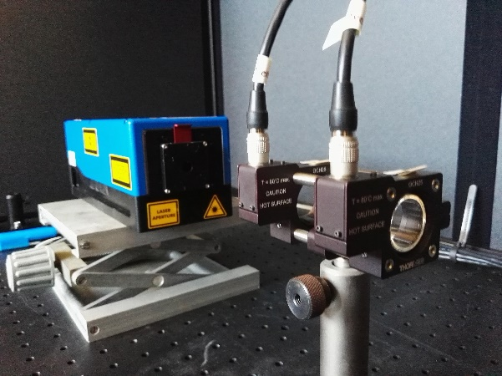

During our project, we will attempt to characterise a new potassium cell, which may be useful in upgrading the BiSON instrumentation. The characterisation will be completed using a tunable laser (one which allows the wavelength to be changed within a small range).

Personal Introductions

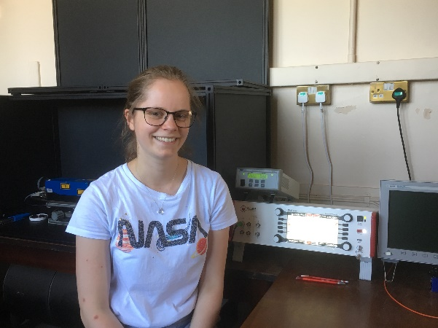

Hello! I’m Emma, and I’ve just completed the third year on the MSci Physics program. I wanted to work on this summer project because I’m interested in astronomical instrumentation, and it’s also a great opportunity to gain experience of working in an academic research group. Throughout my degree, I have done a lot of work on stellar physics but also worked on a variety of projects in the general physics laboratory. This project should give me a chance to pull all of my experience together. I’m not sure yet what I’d like to do after university, I’ll probably apply for a mixture of jobs and PhDs!

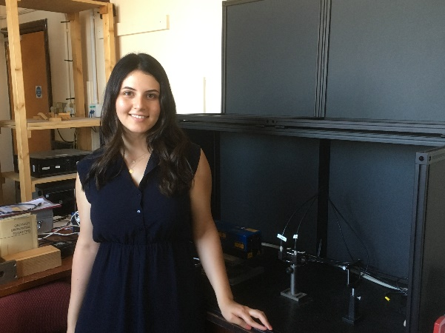

Hello everyone! I am Tutku but everyone knows me as Tuts! I have currently finished the second year of my MSci Physics and Astrophysics degree.  I have decided to gain some work experience this summer, hence I have applied for this summer placement which was a great opportunity for me to see the research team environment! I am highly interested in Extragalactic Astronomy that studies all astronomical objects outside our Milky Way Galaxy. My future Ph.D. path will probably shape towards the Extragalactic Astronomy.

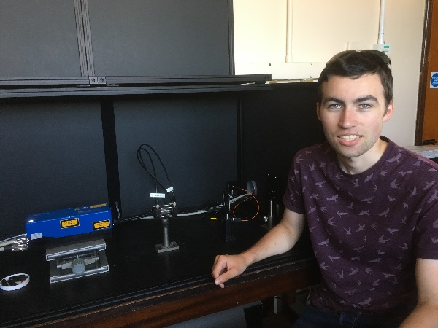Hi all, I’m Dan and I’ve just finished the third year of my four-year Physics and Astrophysics MSci course. Like the others, I’ve always had a strong interest in space, but particularly what you could call ‘small-scale’ astrophysics (though still huge compared to everyday things!), focussing on the physics of stars and planets. Having taken my Y3 Group Studies module in the Asteroseismology group, I now wish to experience a research-based environment that provides a flavour of life as a research/doctoral student; I hope to undertake a PhD following my current undergraduate degree. When not working I can often be found going on otherwise pointless road-trips –- any excuse to drive is good enough for me!